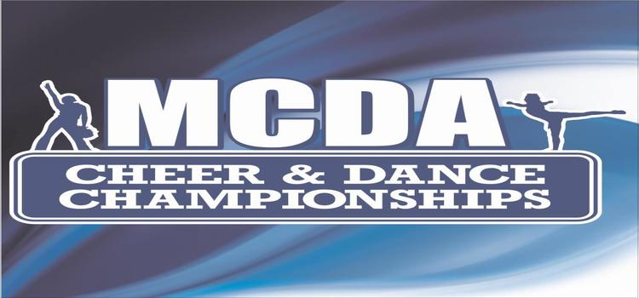  **Program Liability Release Waiver**

I acknowledge and represent that I have collected and have on file a liability waiver (signed by their legal parent or guardian) for each participant I am registering to compete at all MCDA Cheer and Championship events and its subsidiaries. I have verified and each parent represents that their child is in satisfactory health to participate in the activities (cheerleading, gymnastics, dance, etc.) offered by MCDA Cheer and Dance Championships and they are aware of the inherent risks associated with such activities which can include paralysis and death. Each Parent represents they have insurance coverage in effect while they compete at MCDA Cheer and Dance Championships competitions. I will make available to MCDA copies of waivers immediately if requested from time to time. I agree to keep the originals or an acceptable electronic copy of these forms until the participant reaches the age of 18 or 7 years after they are no longer participants in your program. I hereby acknowledge that I am an authorized representative of the business/school listed below.

Program Name Gym Owner/Director

Signed Date

|  |  |  |  |  |  |  |  |
| --- | --- | --- | --- | --- | --- | --- | --- |
| **Liability Release Waiver RE: Copyright Music** | | | |  |  |  |  |
| Event |  |  |  |  |  |  |  |
| Event Date |  |  |  |  |  |  |  |
|  |  |  |  |  |  |  |  |
| Organization |  |  |  |  |  |  |  |
| Address |  |  |  |  |  |  |  |
| Phone No |  |  |  |  |  |  |  |
| Representative Name |  |  |  |  |  |  |  |
| Representative Title |  |  |  |  |  |  |  |
|  |  |  |  |  |  |  |  |
| **Disclaimer:** Music is often protected by copyright and using it without permission from the | | | | | | |  |
| copyright owner can put your organization at risk for claims of copyright infringement.  Copyright | | | | | | | |
| infringement is the use of works protected by copyright law without permission.  Before using | | | | | | | |
| copyrighted or possibly copyrighted materials secure permission.  Midwest Cheerleading & Dance | | | | | | | |
| Academy, Inc. d/b/a MCDA Cheer and Dance Championships, its owner,  any respective directors, | | | | | | | |
| officers, agents, employees, and/or staff) are not liable for any damages, losses or causes of action | | | | | | | |
| of any nature arising from infringement by this organization for using copyrighted (or possible | | | | | | | |
| copyrighted) music and found not in compliance with any music copyright laws. | | | | | |  |  |
| Acknowledged Signature |  |  |  |  |  |  |  |
| Date |  |  |  |  |  |  |  |
|  |  |  |  |  |  |  |  |
| MCDA Staff Signature / Date |  |  |  |  |  |  |  |